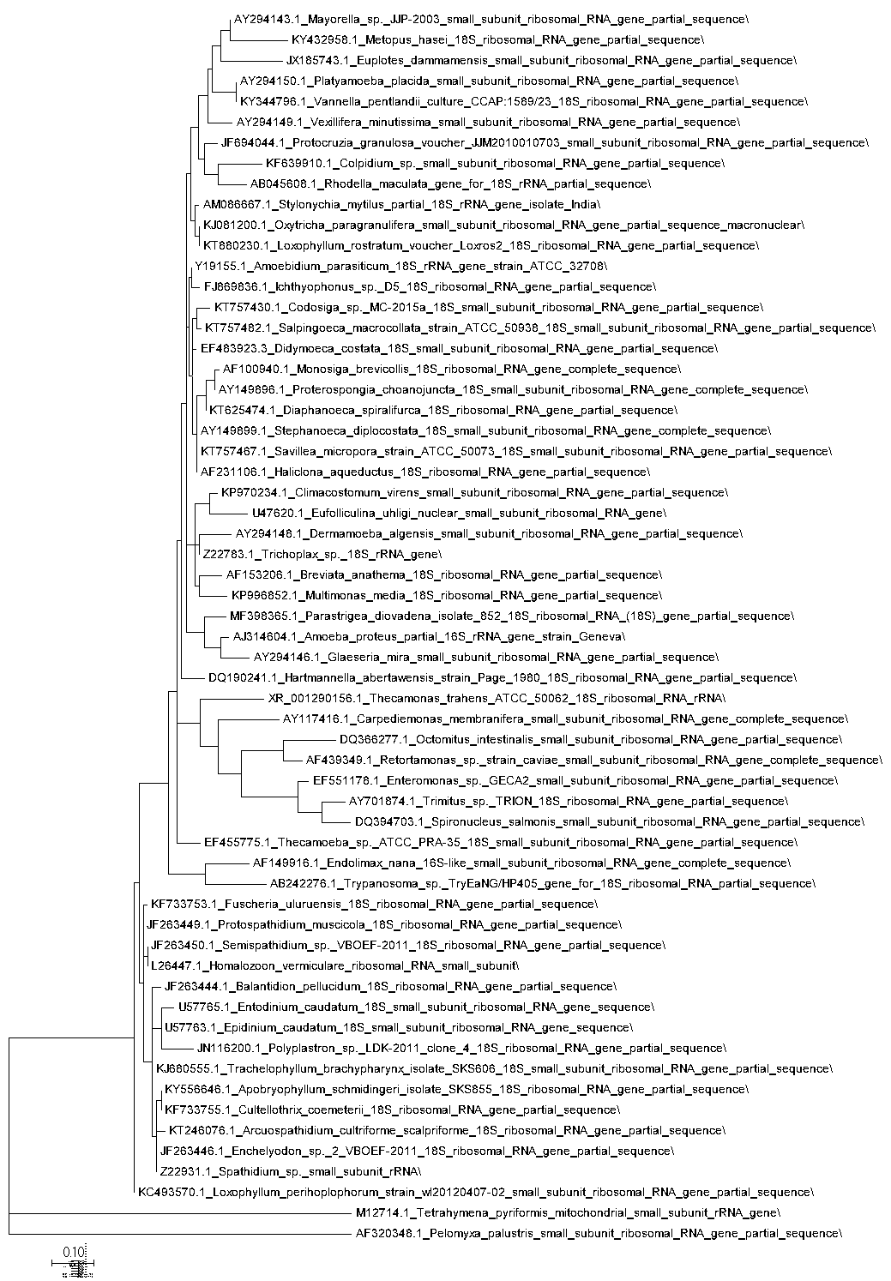MAXIMUM LIKELIHOOD SSU

MAXIMUM PARSIMONY SSU

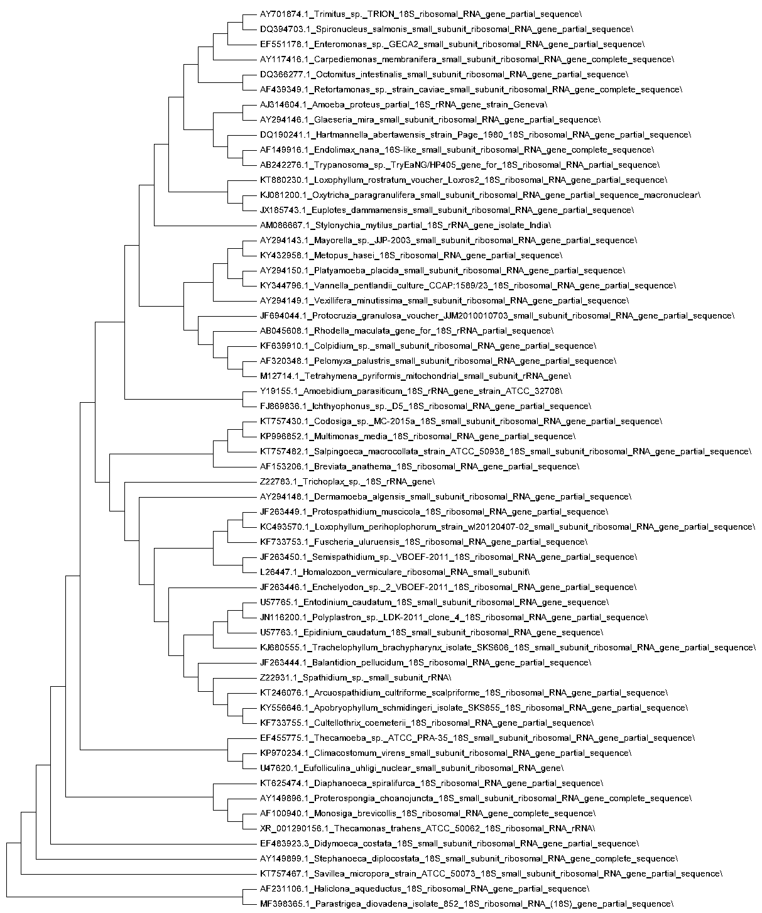

MINIMUM EVOLUTION SSU

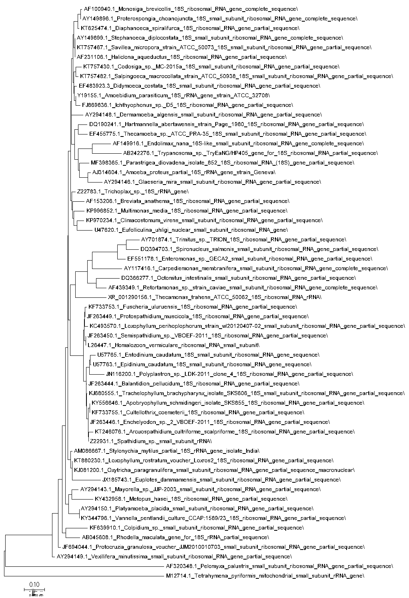

NEIGHBOR-JOINING SSU

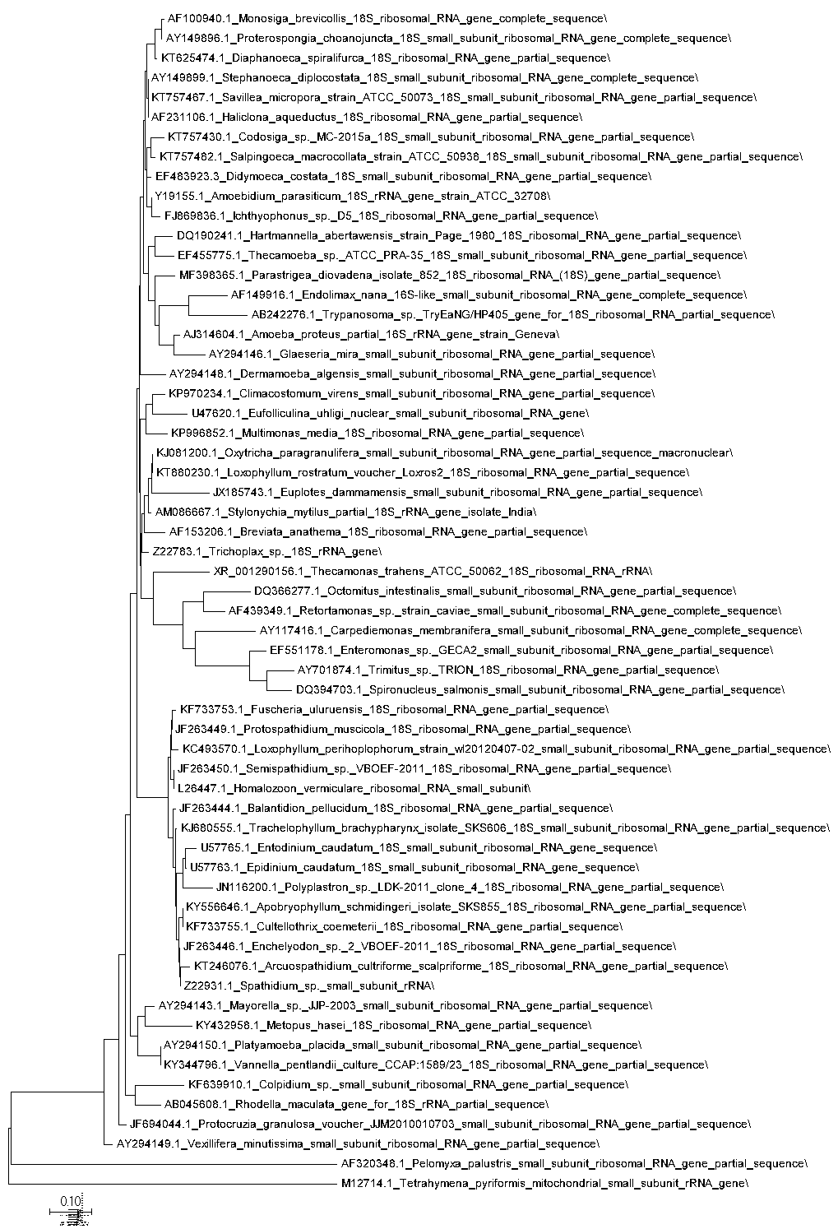

UPGMA SSU

